Product Introduction：3d-laser-reconstruction-scanner


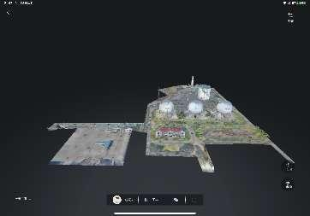

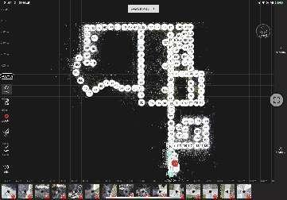
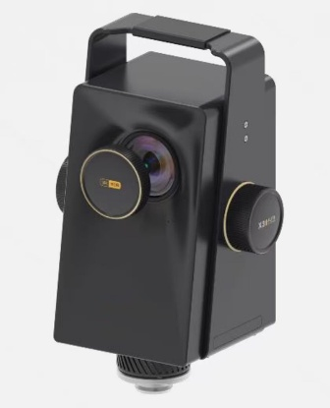

Step 1: Collect data using the equipment
Step 2: Automatic system fusion and stitching
Step 3: Upload Data
Step 4: Generate a 3D model of the crime scene

The 3D crime scene reconstruction system uses a tripod-mounted panoramic laser scanner, a precision scanning device with depth acquisition and color acquisition capabilities. It operates a 3D camera via an app to perform 360° rotation, automatically capturing three-dimensional depth and color information of the space. The system acquires 3D depth information through 3D structured light and performs 3D reconstruction using machine vision SLAM technology, offering advantages such as non-contact, high precision, and real-time performance. HDR technology is also applied to optimize the color information of bright and dark areas in the 3D space. The 3D camera can efficiently capture 720° all-around spatial positioning information on-site, presenting the scene realistically, three-dimensionally, and completely online.
The 3D crime scene reconstruction system is designed for frontline criminal investigation departments and technical departments, focusing on functions such as on-site data collection, 3D scene restoration, 3D scene editing, and 3D scene presentation. The system integrates both software and hardware to achieve on-site data collection, internal network server data processing, and internal network 3D scene editing and display functions.
The data acquisition terminals include: 3D space scanners, scanning software, and scanning software control devices.
Data processing system: 3D data processing system.
Editing and display system: model editing system, front-end display system.

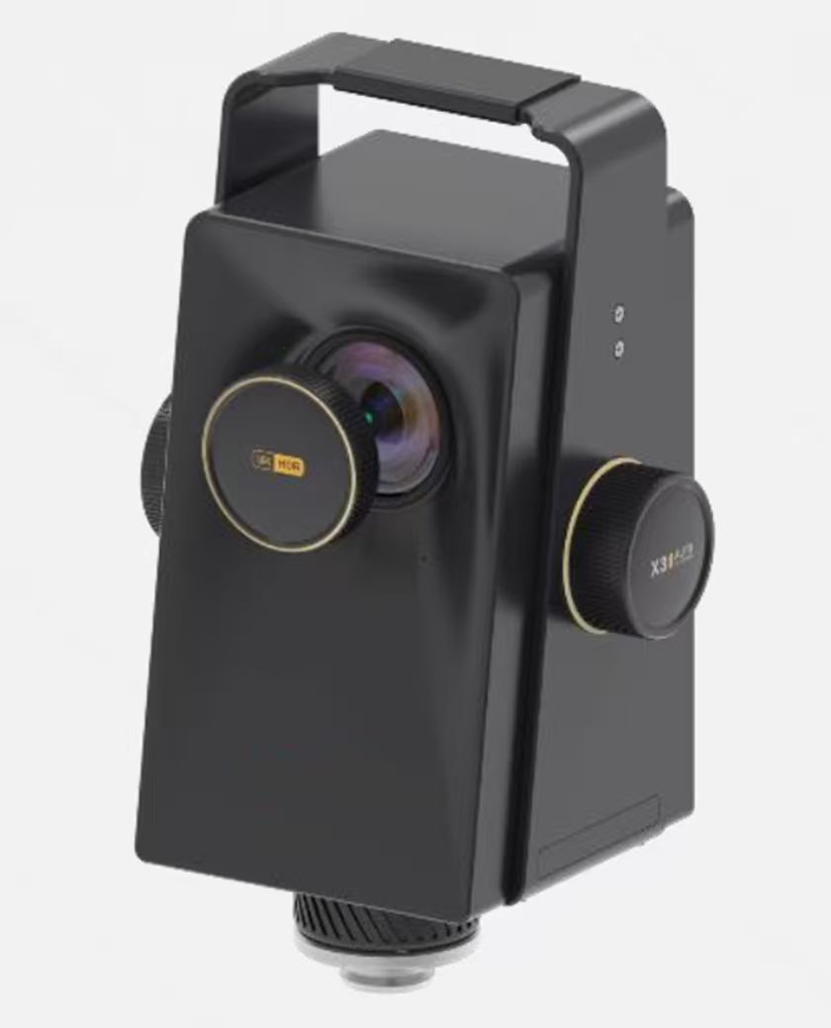
3D Laser Scanner
Large indoor spaces, outdoor scenes, ultra-high precision
Ideal for complex cases involving fire investigation, explosion analysis, and major criminal investigations, enabling rapid intelligent reconstruction of crime scenes.
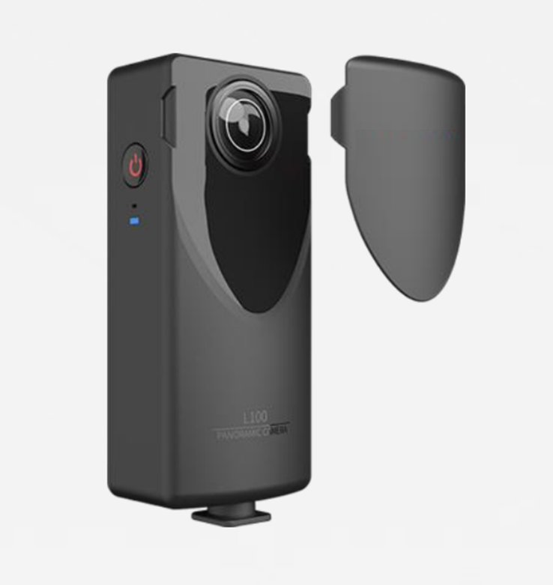

AI 3D Camera

Low-cost, lightweight, portable
Ideal for minor cases like theft, minor injuries, and fraud, enabling case reconstruction and evidence annotation.

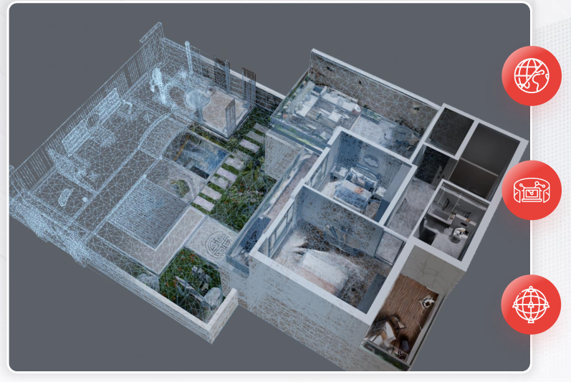

Holographic Replication
Rapidly digitize spaces using spatial reconstruction technology to enhance staff productivity.
Efficiency
Scan 100㎡ sites in just 30 minutes
Immersive navigation with spatial measurement support—annotations instantly visible
Scenario-Based
1:1 replication of real-world 3D spatial models, 100% faithful reproduction of site environments.

3D Spatial Editing Platform
Supports both standalone and server versions, ensuring data security and efficient archiving.

Solutions
Provides technical support for case investigation, disaster simulation and early warning, and critical security operations in public safety scenarios.

I. Criminal Investigation
Seven core functions empower forensic examination of crime scenes
1. Aerial Panoramic & VR Integration
Immersive 3D crime scene navigation faithfully recreates incident locations
Combines oblique photography with air-ground integration capabilities to fuse aerial and indoor perspectives, enabling step-by-step navigation through three-dimensional crime scenes.
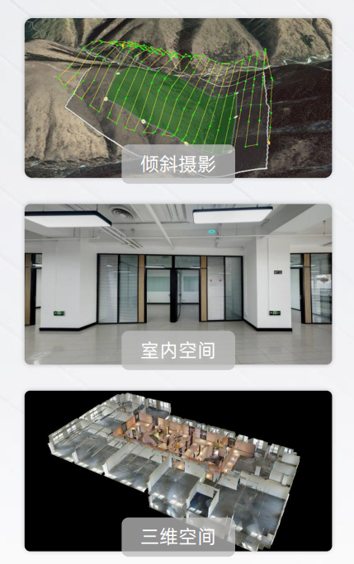

2、Crime Scene Layout Generation
Instantly reconstruct crime scene layouts to restore authentic spatial environments.
Leveraging AI+AR spatial computing capabilities to rapidly generate schematic diagrams of crime scenes, aiding officers in spatial cognition and laying groundwork for incident reconstruction.
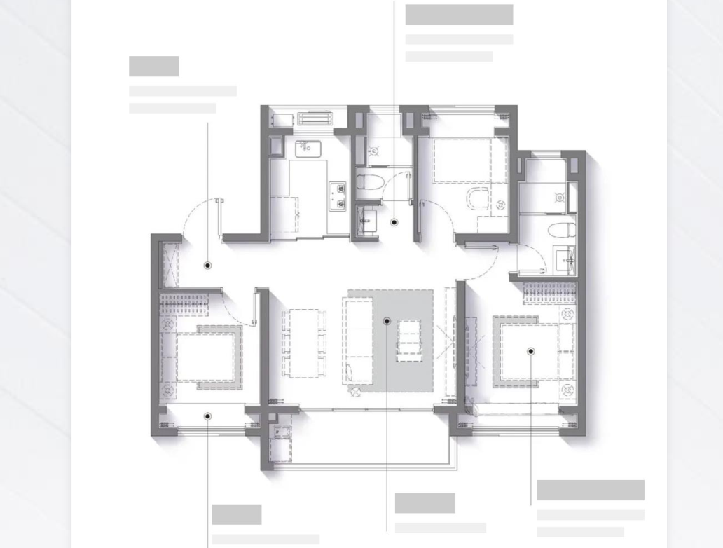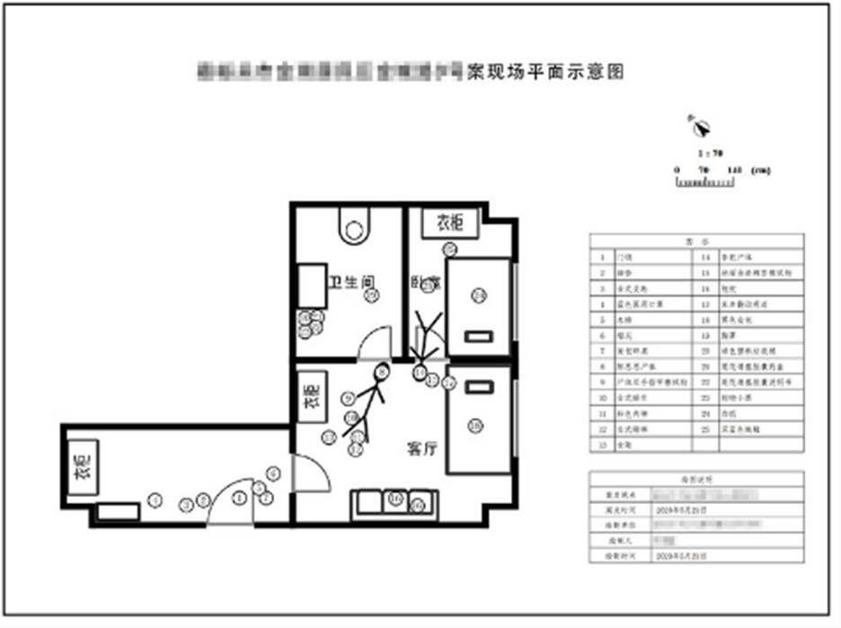

3、Visual Simulation
Authentically recreates crime scenes to support case decision-making

Scene Reconstruction: Utilizes AI+AR technology to realistically recreate the arrangement of objects, positioning of individuals, and placement of tools at crime scenes.

Case Simulation: Officers can simulate the sequence of events and case progression within the actual spatial environment based on the case trajectory, providing three-dimensional, intuitive details of the incident.

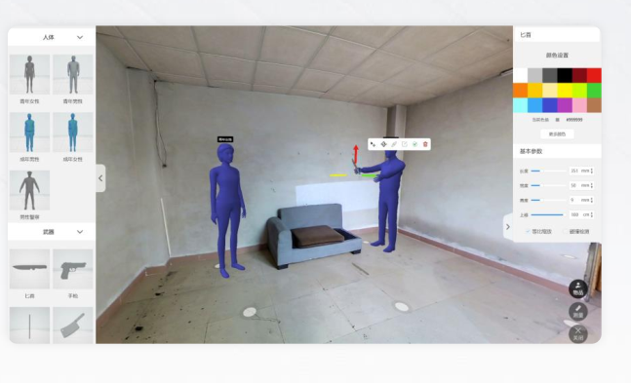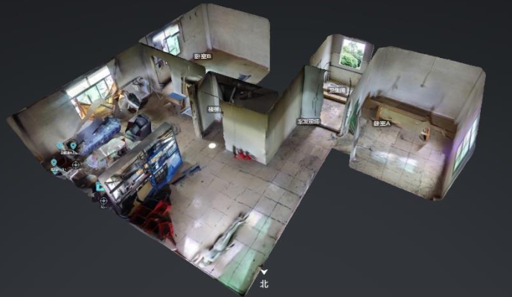

4、Spatial Measurement
Supports dimensional and area measurements within spaces to meet police evidence collection requirements.
Area Measurement
Enables precise area measurements of crime scene evidence to assist officers in making context-specific inferences.
Distance Measurement
Supports real-time, accurate capture of model points to measure evidence distance parameters, providing officers with objective data support with centimeter-level precision.

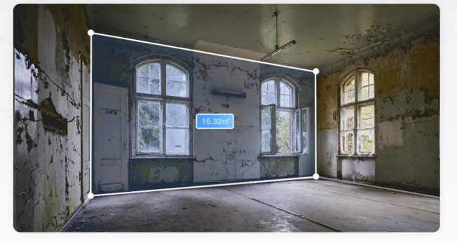

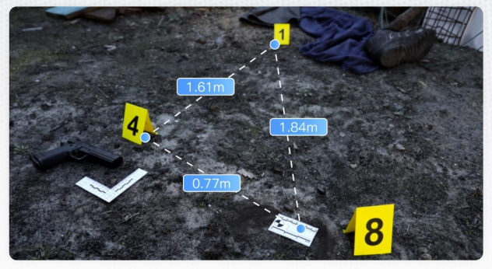

5、Spatial Interaction
Visual Hotspot Annotation + Collaborative Management + Record Archiving & Sharing
Spatial Evidence Hotspot Tags
Add text, video, image, audio, and other tag information within 3D real-world models to assist personnel in event deduction.

Evidence Documentation & Archiving
Utilizing holographic replication technology, permanently preserve complete VR visualization materials and archive them in databases for police case reconstruction.

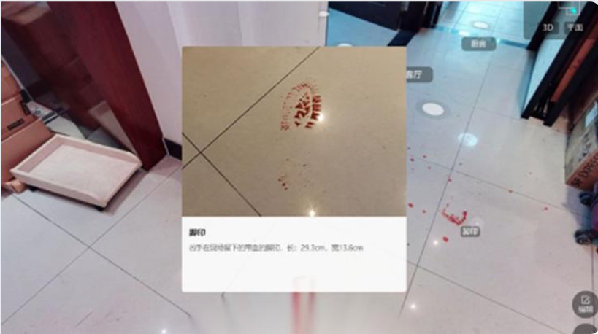

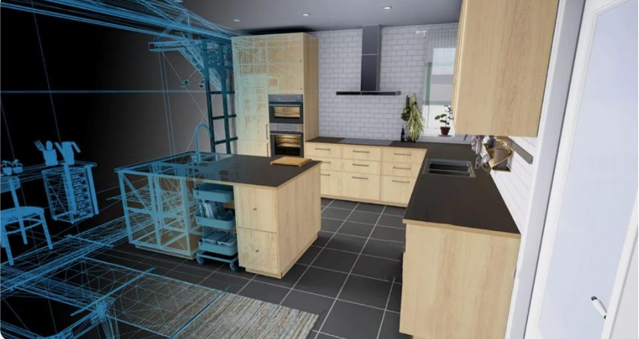

6、Automatic Guided Tour
Simulates the crime scene to help police quickly grasp critical incident details.

Automatic Guided Tour
Generates audio commentary based on key incident details entered, enabling rapid understanding of critical crime scene information.

Case Narration
Authentically recreates the crime scene scenario and simulates the incident trajectory to provide investigators with specific insights and direction.
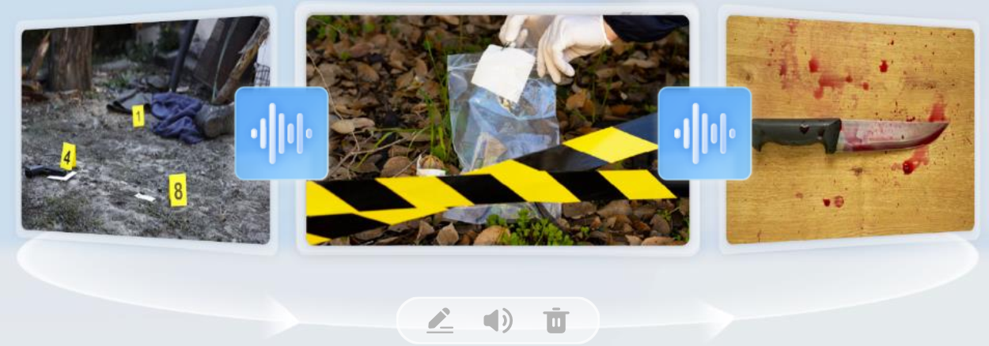

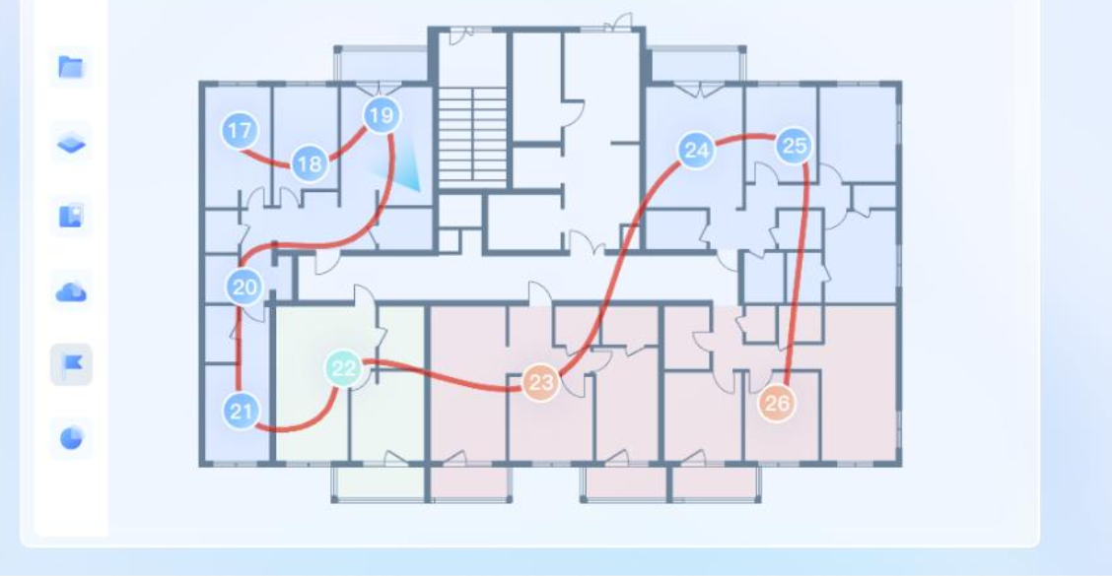

7、Data Sharing
Supports simultaneous online access across multiple devices for seamless collaboration and sharing.
Lightweight browser presentation facilitates easy sharing and discussion.
View crime scene incidents anytime, anywhere to reduce labor costs.
Comprehensive presentation of on-site evidence, physical evidence, and trace details.

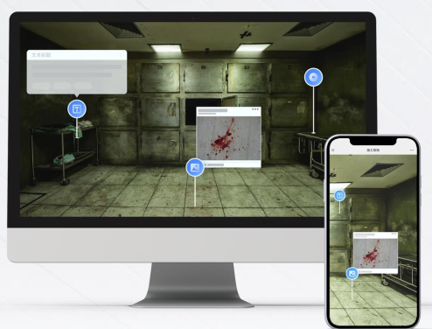

Some partners



